PHYSICAL SCIENCE SKILLS PACKET
FOR INCOMING FRESHMAN STUDENTS OF
TENAFLY HIGH SCHOOL

PRODUCED FOR AND BY THE TENAFLY HIGH SCHOOL
SCIENCE DEPARTMENT FOR EXCLUSIVE USE BY
THE TENAFLY PUBLIC SCHOOLS

INTRODUCTION
This skills packet is designed to acquaint all incoming freshman physical science students with the topics and skills they need to be familiar with and proficient in upon entering the Physical Science course at Tenafly High School. Each student is responsible for reading and doing the exercises in this packet on their own within the first two weeks of the school year. Students are strongly advised to make use of additional sources beyond this packet to enhance their understanding of these topics. These can include things such as your textbook for this class or other similar textbooks, websites, or notes from previous science classes. Students will be tested on these skills and topics by their individual classroom teachers at some point shortly after the first two weeks of school has elapsed.

These are the topics and skills you are to be familiar with and proficient in:
- The Metric System
- Conversions: metric to metric
- Scientific Notation
- Units of Measurement
- Rounding
- Properties of Matter: mass, weight, volume, density
- Using the Ruler
- Triple Beam Balance
- Graduated Cylinder
- The Scientific Approach
- Techniques of Graphing

Power Point Files
To help you begin your study of these topics, review 2 power point files by going to:
http://hs.tenafly.k12.nj.us/ -> Staff Profiles -> Matthew White -> Physical Science CPA -> 1st Semester (Chemistry) -> Chapter 1: Science Skills

2 Power Point Files:
- Units and Measurement - Chapter 1
- Intro to Physical Science - Chapter 1

Section 1: The Metric System

The Metric system is a system of measurement based on multiples of 10. It is the primary system of expression for units of measure in scientific work. The following pages have information and exercises on: the metric system, conversions within this system, how to use and express numbers in scientific notation, units of measure in the metric system, and how these units relate to one another and what they me

What is the basic unit of length in the metric system? ___________________
What is the basic unit of mass in the metric system? ___________________
What is the basic unit of time in the metric system? ___________________

As you know the metric system is based on the number ten and multiples of ten. You can express a measurement as a multiple of the basic unit or you can use one of the prefixes that are used in the metric system. What is the prefix (and its abbreviation) for each of the following multiples of ten?

10⁻⁶ or .000001 = ______________________________________

10⁻³ or .001 = ______________________________________

10⁻² or .01 = ______________________________________

10⁻¹ or .1 = ______________________________________

10⁰ or 1 = ______________________________________

10¹ or 10 = ______________________________________

10² or 100 = ______________________________________

10³ or 1000 = _____________________________________
10⁶ or 1000000 = _____________________________________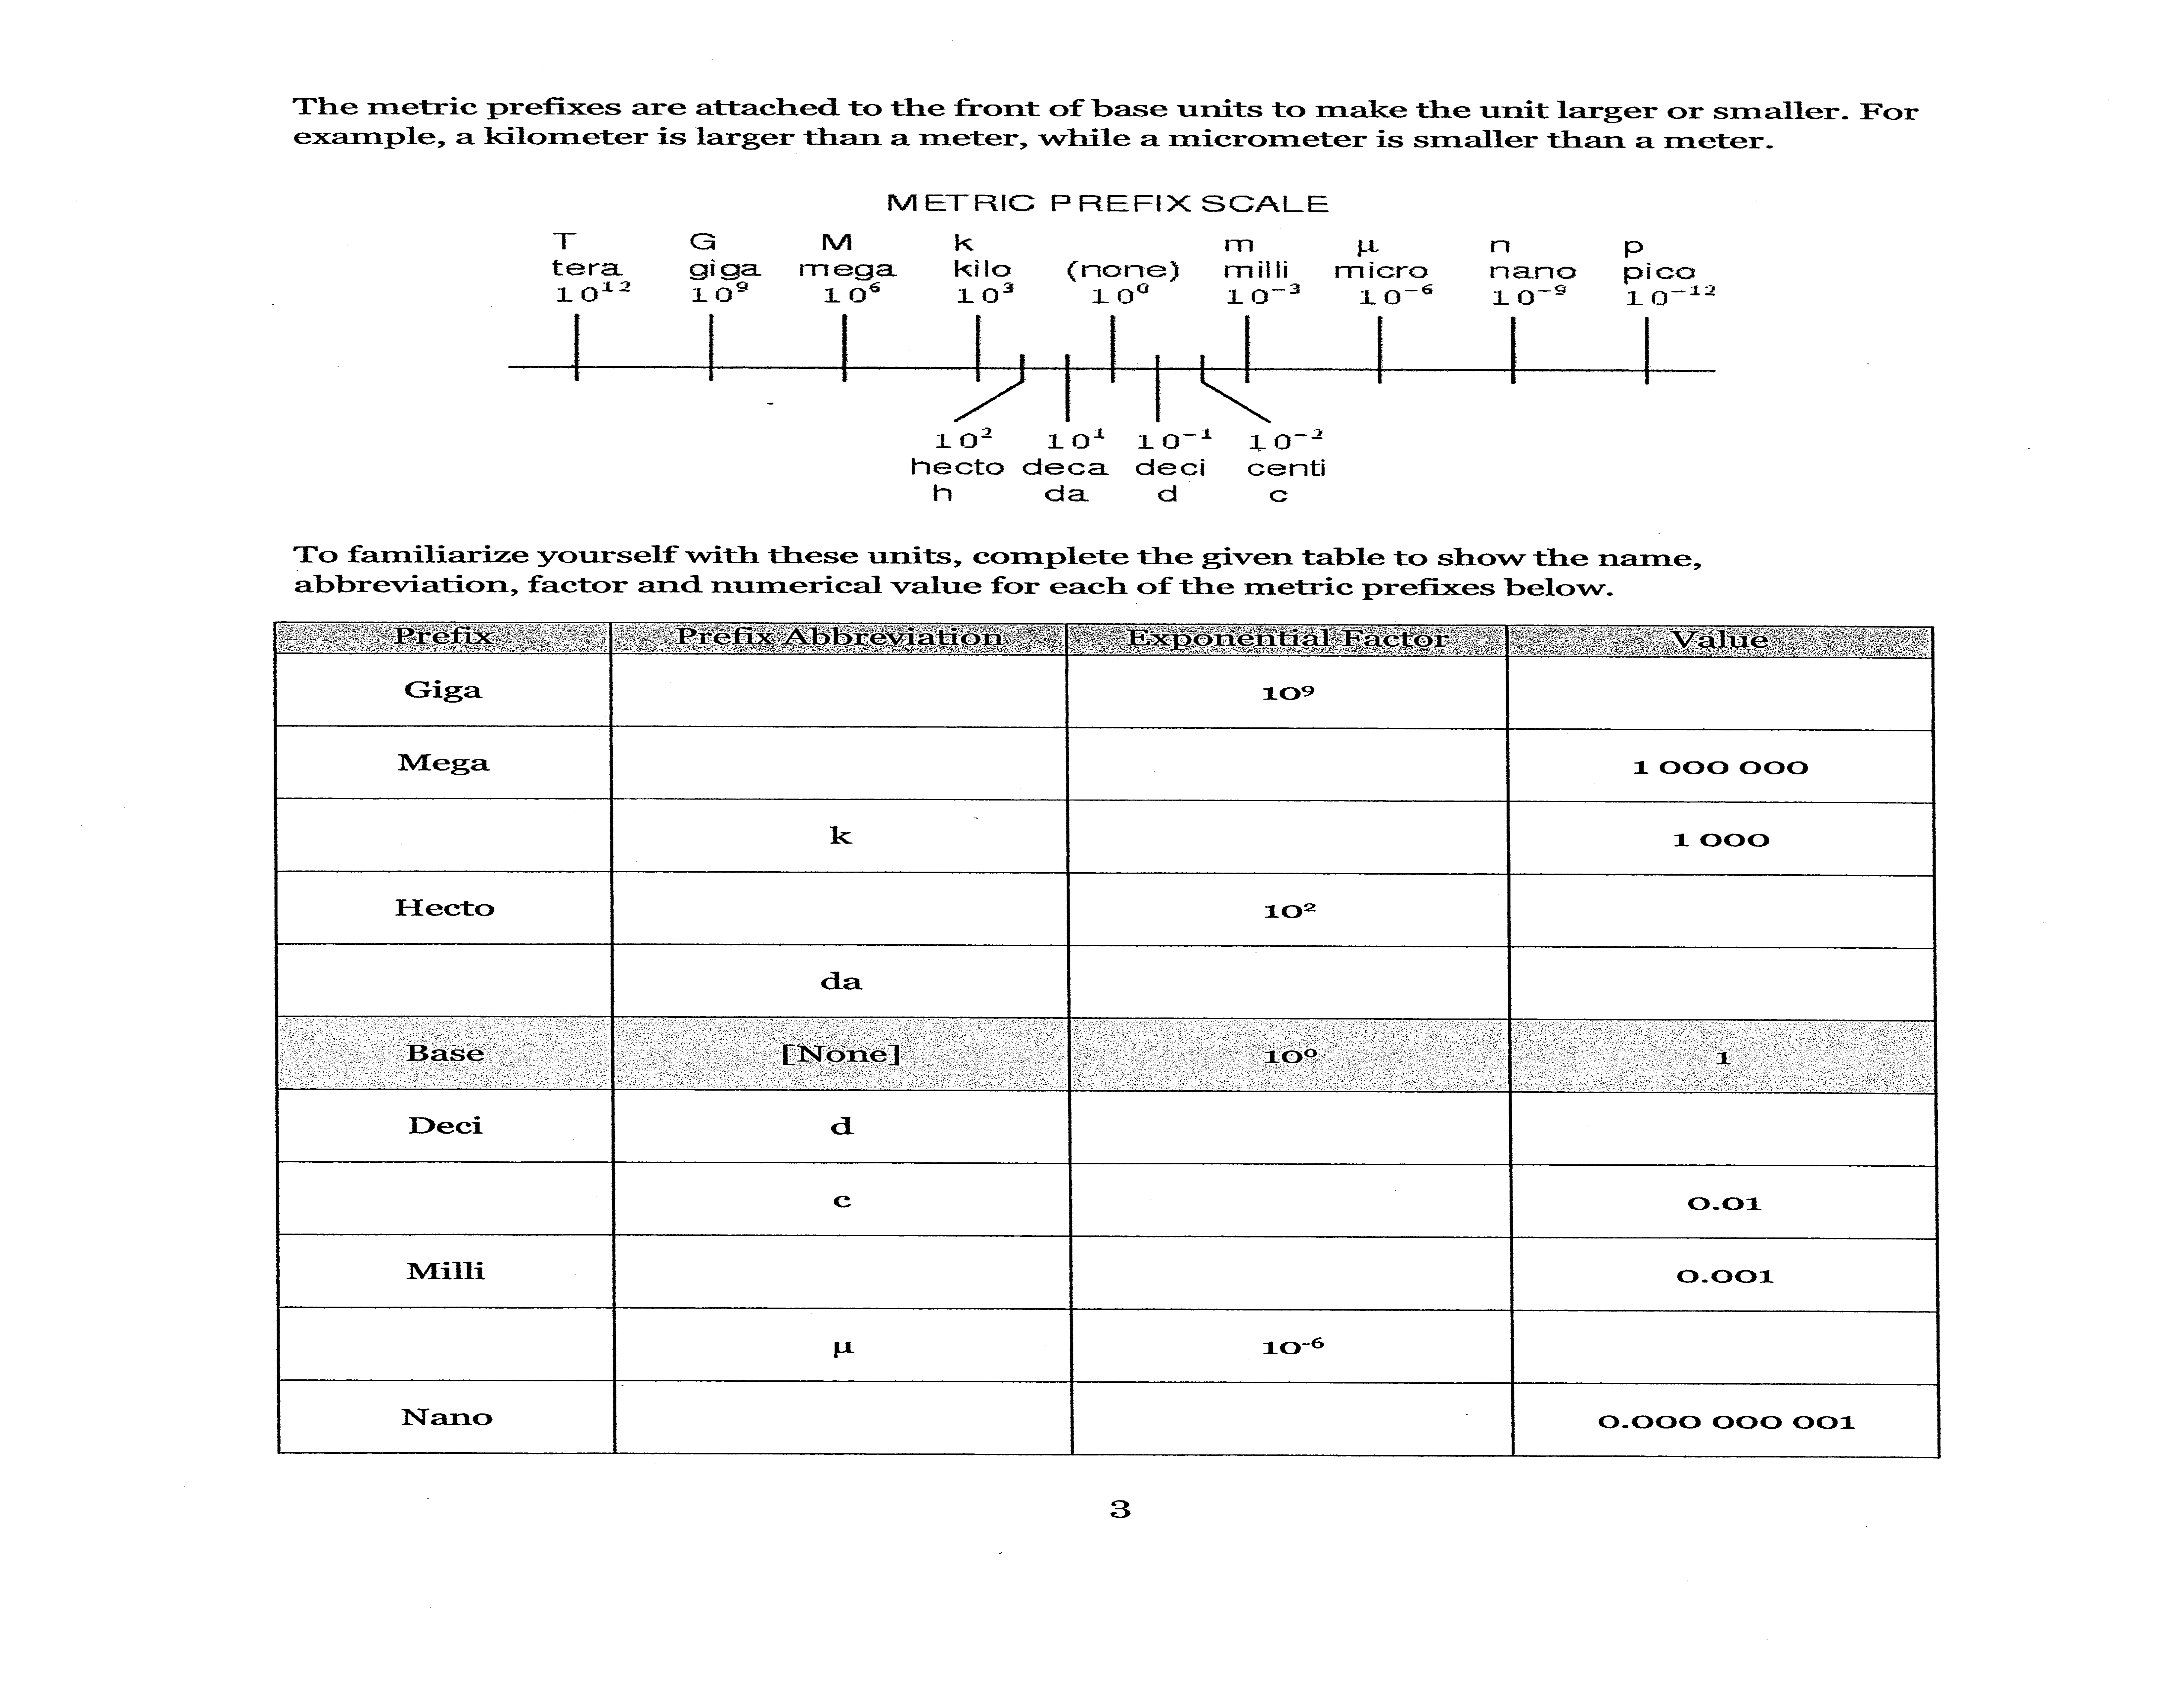
All numbers in science must have units. Units in the metric system have two parts: the base unit and the prefix.

The base unit tells us what the number represents. Examples are:
- Grams (g) for mass
- Liters (l) for volume
- Meters (m) for distance

The prefix tells us that the number is multiplied by a certain value. Therefore, if we want to express a small distance we might want to use centimeters (cm). The centi- tells us that the distance is recorded in hundredths of a meter. Thus 23 cm would represent 23 hundredths of a meter

Section 2: Conversions: metric to metric

Sample Problem
Armando stepped on the scale in his doctor’s office and found out that his mass is 35 kg. What is his mass in grams?

Step 1. List the given and unknown values.
Given: mass in kilograms_35 kg
Unknown: mass in grams_? g
Step 2. Write the equation for the conversion.
You will multiply your given by a conversion factor. A conversion factor is a fraction in which the numerator equals the denominator. In the example below, $\frac{1000g}{1kg}$ is the conversion factor and we can see that the numerator (1000g) equals the denominator (1kg.) What you are converting from must be in the denominator of your conversion factor.

mass in g = mass in kg x 1000 g
1 kg

Step 3. Check that your equation makes sense

By using the table below, you know that you will multiply because it takes a lot of grams to make up each kilogram. Specifically in this case it takes 1000g = 1kg

Step 4. Insert the known values into the equation, and solve.
mass in g = 35 kg x 1000 g
1 kg
mass in g = 35,000 g

Prefix | Symbol | Meaning | Multiple of base unit
mega- | M | million | 1,000,000
kilo- | k | thousand | 1000
deci- | d | tenth | 0.1
centi- | c | hundredth | 0.01
milli- | m | thousandth | 0.001
micro- | µ | millionth | 0.000001

Answer these questions in the space provided. Show your work and include the units.
1. On March 24, 1989, the Exxon Valdez struck a reef in Prince William Sound, Alaska, spilling 37,854,120 L of crude oil. What is this volume in milliliters?

2. The Tent meteorite, found in 1897 near Cape York, on the west coast of Greenland, is the largest meteorite exhibited by any museum. It has a mass of 30,883 kg. How much is the mass of this meteorite in milligrams?

3. Speed skater Kim Ki-hoon, of South Korea, won the 1000 m short track race in the 1992 Olympics with a time of 90.76s. How many milliseconds did it take him to finish the race? How many centimeters long was the race?

Sample Problem
A very thin thread has a thickness of 4 x 10⁻⁶m. What is the thickness of this thread in micrometers (µm)?

Step 1. List the given and unknown values.
Given: thickness in meters = 4 x 10⁻⁶m
Unknown: thickness in micrometers_? µmStep 2. Write the equation for the conversion.
thickness in µm = thickness in m x 1 µm
1 x 10⁻⁶m

Step 3. Check that your equation makes sense
Using the table above, you can see that you will have many more µm than meters.

Step 4. Insert the known values into the equation, and solve.
thickness in µm = 4 x 10⁻⁶ m x 1 µm
1 x 10⁻⁶m
thickness in µm = 4 µm

Practice
4. One of the smallest species of insects in the world is Caraphractus cinctus, a type of wasp. The average mass of this wasp is 5 µg. Convert this mass into grams.

5. Scientists studying bull sperm whales off the coast of South Africa have calculated that these mammals can descend to depths of nearly 3000 m during their search for food. What is this depth in kilometers?

6. Laura runs a 100 m race in 20.0 s. What is her time in kiloseconds? How long is the race in kilometers?

7. It does not take a large electric current, the amount of charge that passes through a substance each second, to cause a fatal shock. The smallest deadly amount of electricity through the human body is 100 mA (milliamperes). What is this current in amperes?

8. Pikes Peak is a mountain in Colorado. Its height is 4301 m above sea level. What is this altitude in kilometers?

9. Yosemite Falls, in California, has a total height of 73,900 cm. What is this height in meters?

10. The Rio Grande is the river between Texas and Mexico, but not everyone realizes that it begins in Colorado and flows through New Mexico. The river’s total length is 3,033,000 m. How many kilometers is this?

Conversion Practice Answers
- 3.79 x 10 ¹⁰ mL
- 3.0883 x 10 ¹⁰ mg
- 90760 ms 1000000 cm
- 5 x 10 ⁻⁶ g
- 3 km
- 0.02 kg 0.1 km
- 0.1 Amps
- 4.301 km
- 739 m
- 3033 km
MORE CONVERSION PRACTICE
Each of the following measurements has been expressed using a particular metric prefix. Rewrite the measurement using the given prefix.

1) 3.7 km = ____________________ dm

2) 48 mm = ____________________ dam

3) 395 ml = ____________________ l

4) 29 A = ____________________ mA

5) 63 cg = ____________________ hg

6) 678 g = __________________ cg

7) .02 kl = __________________ dl

8) .49 MW = __________________ kW

9) .93 dm = __________________ cm

10) .5 mA = __________________ A

Answers

- 37000 dm
- 0.0048 dam
- 0.395 l
- 29000 mA
- 0.0063 hg
- 67800 cg
- 200 dl
- 490 kW
- 9.3 cm
- 0.0005 A

Section 3: Scientific Notation
- Why do we need scientific notation?

Big things:
Mass of the sun is 1989100000000000000000000000000 kilograms
Distance from Earth to sun is 149600000000 meters
Small things:
Mass of an electron is 0.00000000000000000000000000000091 kilograms
Diameter of a proton is 0.0000000000000017 meters
The numbers above are obviously cumbersome to write and use in calculations.
Scientific notation allows us to easily express large and small numbers and perform calculations with them.
For example, after reading this packet, you will be able to do the following calculations easily without a calculator:
20000000000 X 3000000 = ?
0.000000006 / 200000 = ?

- How do we express numbers in scientific notation?
  - Let’s start by looking at some examples
    - We know that:
5.6 x 10000 = 56000
3.3 x 100 = 330
    - We can also say:
10000 = 10⁴
100 = 10²
    - So:
5.6 x 10⁴ = 56000
3.3 x 10² = 330

  - Formal definition of scientific notation
    - A number in scientific notation is expressed as:
M x 10^{n}
where:
M is the coefficient
1<M<10 (M is between 1 and 10. The decimal point is always after the first digit)
n is the exponent
n can be any integer

  - Using scientific notation
    - To convert from scientific notation to a “regular” decimal number or “long format,” we start with M (coefficient) and move the decimal point by n places.
    - We move the decimal point RIGHT if n is POSITIVE
    - We move the decimal point LEFT if n is NEGATIVE

    - Examples:
1.2 x 10³ = 1200 -2.43 x 10⁴ = -24300
5.09 x 10⁵ = 509000 -4.08 x 10⁻⁶ = -0.0000408
1.2 x 10⁻³ = 0.0012 -2.43 x 10² = -243
5.09 x 10⁻⁵ = 0.0000509 -4.08 x 10⁻³ = -0.00408

Scientific Notation Practice
Put the following numbers into scientific notation.
- 984000000 __________________________________

- 0.0000003478 __________________________________

Take the following numbers out of Scientific Notation
- 9.4 x 10 ⁶ __________________________________

- 1.5 x 10 ⁻³ __________________________________

Scientific Notation Practice Answers
- 9.84 x 10 ⁸
- 3.478 x 10 ⁻⁷
- 9400000
- 0.0015

ADDITIONAL PRACTICE PROBLEMS

Write the following in correct scientific
notation:
- 350 =
- 2500 =
- 450000 =
- 7600000 =
- 0.0145 =
- 0.98
- -0.000319 =
- -0.00213
- 498.78 =
- -590020 =
- 0.00205 =

Write the following in “long” form:
- 5 x 10³ =
- 5 x 10⁻³ =
- -5.02 x 10³ =
- 5.02 x 10⁻³ =
- -6.701 x 10⁶ =
- 2.41 x 10⁻⁵ =

Answers

- 3.5 x 10²
- 2.5.5 x 10³
- 4.5 x 10⁵
- 7.6 x 10⁶
- 1.45 x 10⁻²
- 9.8 x 10⁻¹
- -3.19 x 10⁻⁴
- -2.13 x 10⁻³
- 4.9878 x 10²
- -5.9002 x 10⁵
- 2.05 x 10³
- 5000
- 0.005
- -5020
- 0.00502
- -6701000
- 0.0000241

- Arithmetic w/ Scientific Notation
INTRODUCTION: You will use your calculator for arithmetic with scientific notation. However, it is important to understand how this arithmetic is done so you can quickly estimate your answer. This way you can catch errors in entering numbers in your calculator.

When multiplying, dividing, adding or subtracting two numbers in scientific notation, use the rules (and table) below:

  - Multiplication
    - Multiply the coefficients
    - Add the exponents
  - Division
    - Divide the coefficients
    - Subtract the exponents
  - Addition
    - Set exponents the same
    - Add coefficients
    - Keep exponents the same
  - Subtraction
    - Set exponents the same
    - Subtract coefficients
    - Keep exponents the same

Examples:

(4 x 10²) x (2 x 10⁴) = 8 x 10⁸
(5 x 10⁷) x (1 x 10³) = 5 x 10¹⁰
(3 x 10³) x (2 x 10⁻⁵) = 6 x 10⁻²

(8 x 10⁴) / (2 x 10²) = 4 x 10²
(5 x 10⁷) / (1 x 10³) = 5 x 10⁴
(9 x 10³) / (3 x 10⁵) = 3 x 10⁻²

(4 x 10⁴) + (2 x 10⁴) = 6 x 10⁴
(5 x 10³) + (1 x 10³) = 6 x 10³
(3 x 10⁻⁵) + (2 x 10⁻⁵) = 5 x 10⁻⁵

(4 x 10⁴) - (2 x 10⁴) = 2 x 10⁴
(5 x 10³) - (1 x 10³) = 4 x 10³
(3 x 10⁻⁵) - (5 x 10⁻⁵) = -2 x 10⁻⁵

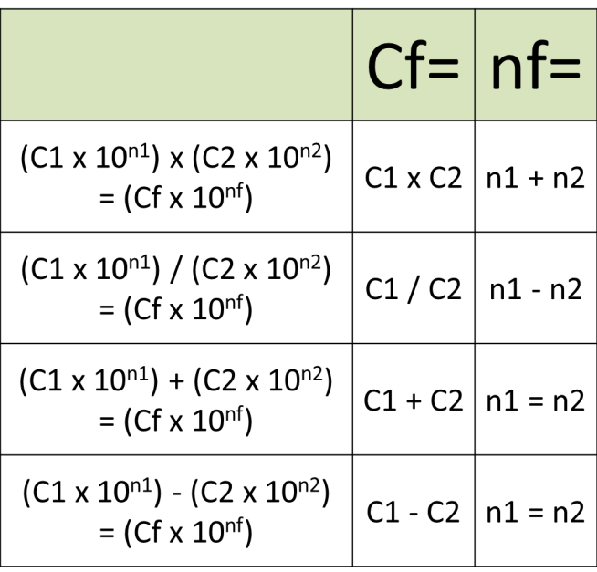

PRACTICE PROBLEMS:

- Multiplication (Do the without a calculator)
  - (3 x 10³) x (2 x 10⁴) =
  - (3 x 10⁹) x (-1 x 10²) =
  - (2 x 10⁻³) x (2 x 10⁵) =
  - (-3 x 10⁻⁴) x (-3 x 10⁻⁷) =

- Division (Do the without a calculator)
  - (9 x 10⁶) / (3 x 10²) =
  - (-3 x 10⁹) / (1 x 10²) =
  - (2 x 10⁻³) / (2 x 10⁵) =
  - (6 x 10⁻⁴) / (2 x 10⁻⁷) =
  - (4 x 10²) / (2 x 10⁻³) =

- Addition (Do the without a calculator)
  - (4 x 10⁴) + (3 x 10⁴) =
  - (-2 x 10⁻⁶) + (6 x 10⁻⁶) =
  - (6 x 10⁵) + (1 x 10⁵) =
  - (8 x 10⁸) + (9 x 10⁸) =
  - (4 x 10⁻⁵) + (8 x 10⁻⁵) =

- Subtraction (Do the without a calculator)
  - (4 x 10⁴) - (3 x 10⁴) =
  - (8 x 10⁻⁶) - (6 x 10⁻⁶) =
  - (6 x 10⁵) - (-1 x 10⁵) =
  - (8 x 10⁸) - (9 x 10⁸) =
  - (4 x 10⁻⁵) - (-8 x 10⁻⁵)
Calculate. Answers should be in scientific notation
- (5 x 10 ⁹) (4 x 10 ⁴) __________________________________

- (7 x 10 ⁻³) (6 x 10 ⁻²) __________________________________

- (8 x 10 ⁻²) (2 x 10 ⁸) __________________________________

- (9 x 10 ⁵) / (3 x 10 ²) __________________________________

- (10 x 10 ³) / (2 x 10 ⁻⁶) __________________________________

ANSWERS

  - 6 x 10⁷
  - -3 x 10¹¹
  - 4 x 10²
  - 9 x 10⁻¹¹

  - 3 x 10⁴
  - -3 x 10⁷
  - 1 x 10⁻⁸
  - 3 x 10³
  - 2 x 10¹

  - 7 x 10⁴
  - 4 x 10⁻⁶
  - 7 x 10⁵
  - 1.7 x 10⁹
  - 1.2 x 10⁻⁴

  - 1 x 10⁴
  - 2 x 10⁻⁶
  - 7 x 10⁵
  - -1 x 10⁸
  - 1.2 x 10⁻⁴
- 2.0 x 10 ¹⁴
- 4.2 x 10 ⁻⁴
- 1.6 x 10 ⁷
- 3 x 10 ³
- 5 x 10 ⁹

Rewrite each of the following numbers, changing each to scientific or normal notation.

- 123000 = ______________________ 2.46 X 10³ = _________________________

- 0.734 = ______________________ 5.82 X 10⁻⁵ = _________________________

Do each of the following calculations. Use your calculator. Record your answer in scientific notation.

- (3.85 X 10⁻³m) (8.39 X 10⁵m) = _____________________________

- (7.57 X 10⁸ km) / (2.64 X 10³ hr) = _____________________________

Answers: 10) 1.23 x 10⁵, 2460; 11) 7.34 x 10⁻¹, 0.0000582; 12) 3.23 x 10³m²; 13) 2.87 x 10⁵km/hr

Section 4: Units of Measurement
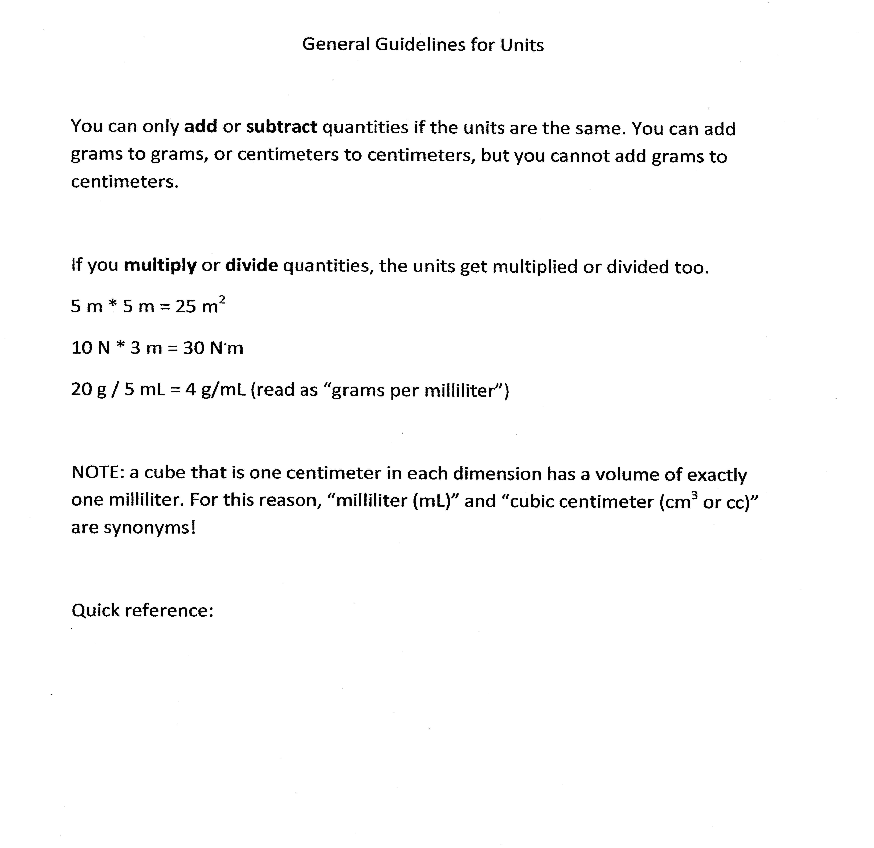
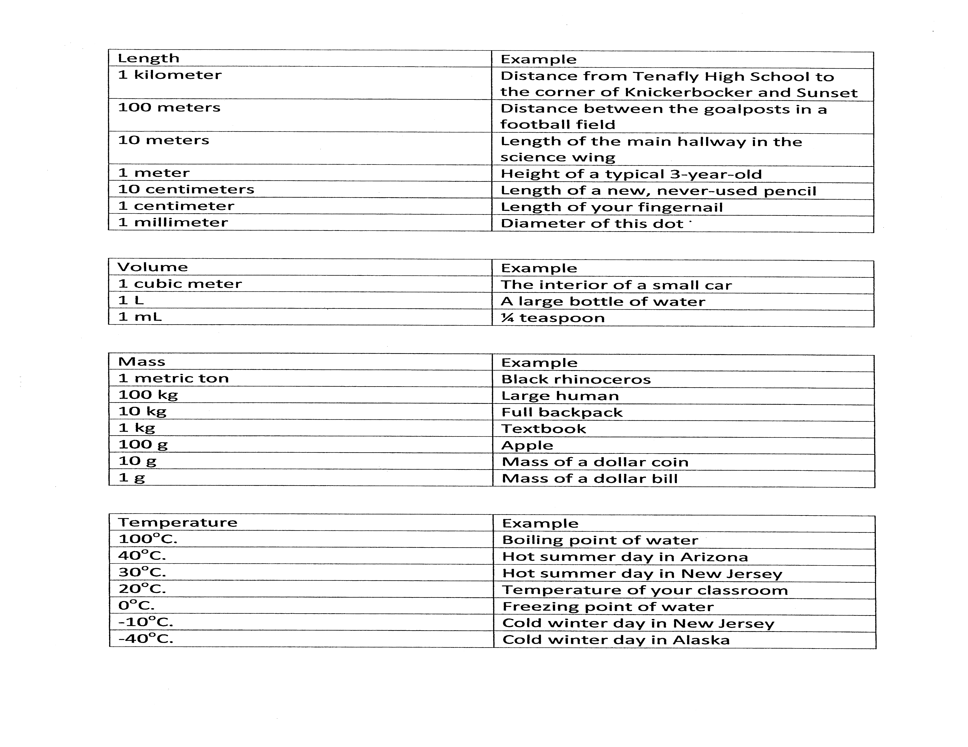
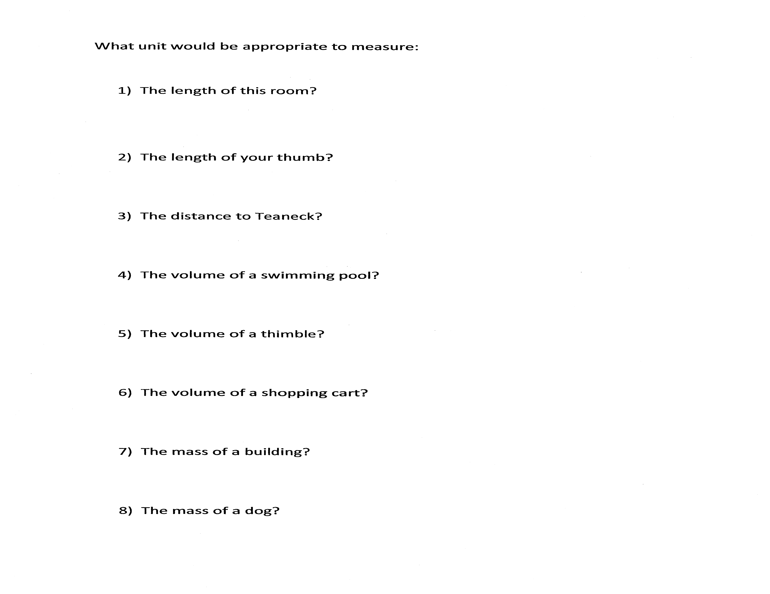

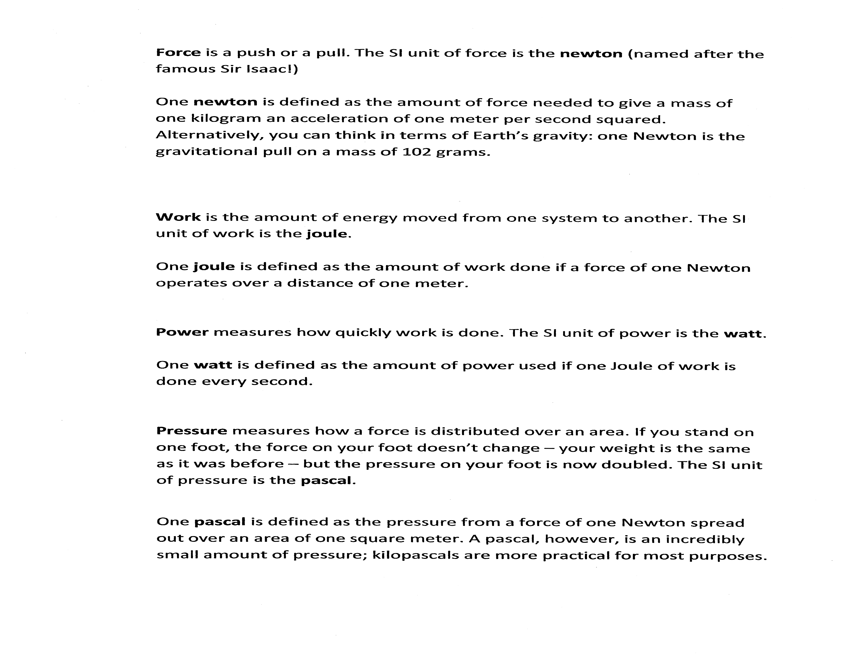

Section 5: Rounding

Many laboratory investigations require you to measure something and then do calculations with the measurements. In class all of the numbers that you work with in problems are considered to have been measurements. Let’s say that you measured the mass of a block to be 246g and its volume to be 23cm³. If you calculate the density of the block you would get 10.695652 g/cm³. The problem is; how should you round off your calculated results so that they reflect the precision of your original measurements?
In the lab, when you measure something, you record all the digits your instrument allows, even if it is a zero. The last digit recorded is always an estimate that is 0.1 of the smallest division of the instrument. The recorded digits are called significant digits.
When you do calculations with measurements, your answer can only have one uncertain digit. In the following examples the last digit recorded (underlined) is an estimate and is therefore uncertain.

Example: 2.45 since you can see that the answer will
3.579 have its first uncertain digit in the
+ 19.34583 hundreds place, round off your other
-------- numbers to this place and then add.
25.38

Example: 2.234 you cannot see where to round off
x 1.1 beforehand, therefore you multiply and
------ then round off so that you only have
.2234 one uncertain digit.
2.234
------
2.4574 = 2.5
How do you recognize if a digit is significant?
1. All nonzero digits are always significant.
2. All final zeros after the decimal point are significant.
3. Zeros between two significant digits are significant.
4. Zeros used for keeping track of the decimal point are not significant

Measurement | Number of significant digits | Measurement | Number of significant digits
321 | 3 | 540.0 | 4
0.123 | 3 | 0.0750 | 3
450 | 2 | 8305 | 4
0.056 | 2 | 4.03060 | 6

The following site will let you practice counting the number of significant digits in a number.
http://science.widener.edu/svb/tutorial/sigfigures.html
Multiplication and division answers are limited by the least precise measurement as are combined calculations. To round off an answer look at the original measurements. Count the number of significant digits in each number. The answer needs to be rounded so that it has the same number of significant digits as the least precise measurement.
In the original density example 246g has 3 significant digits and 23cm³ has 2 significant digits. The answer (10.695652 g/cm³) needs to be rounded to 2 significant digits which gives 11g/cm³

Try the following problems. Remember that in science, units are as important as the numbers

1) 16.2 m + 5.008 m + 13.48 m =
2) 5.006 m + 12.0077 m + 8.0084 m =
3) 78.05 cm² - 32.046 cm² =
4) 15.07 kg - 12.0 kg =
5) (6.2 X 10¹⁸ m)(4.7 X 10⁻¹²m) =
6) (5.6 X 10⁻⁷ m)/(2.33 X 10⁻¹²s) =
7) 2500/155 =

Answers
- 34.7 m
- 25.022 m
- 46.00 cm²
- 3.1 kg
- 2.9 x 10⁷m²
- 2.4 x 10⁵m/s
- 16

Section 6: Properties of Matter: Mass, Weight,
Volume, Density

- Mass is the quantity of matter in an object or sample, it’s base unit is a kilogram (kg).
- Volume is the amount of space taken up by an object, it’s base unit is meters cubed (m³).
- Weight is the force of gravity acting on an object, it’s base unit is a newton (N).
- Density is the ratio of an object’s mass to its volume,
it’s base unit is kg/m³.

On the following pages are some exercises and calculations involving these properties of matter.

Basic Concepts and Measurements in Properties of Matter.

Once students learn the concept of length as a linear dimension and its measurement with a ruler, the student can progress to the concepts and measurements of two–dimensional space and thus finally three–dimensional space or volume.
01. Volume (V) is the amount of space occupied by matter and in the case of regular 3-dimensional geometries, such as regular parallelepipeds or blocks there is a simple formula relating the height (H), width (W) and length (L) to its volume (V). Volume is a derived unit. A derived unit is a unit made up of several basic units

V = HWL

H

W
L

The linear dimensions are measured in meters in the SI system of units and the volume in cubic meters or m³.
(a) Given a room whose height = 1.40 m and width = 9.50 m and length = 12.7 m, find its volume.

V = HWL = (1.40 m)(9.50 m)(12.7 m) ≈ 169 m³

02. Mass (m) is the quantity of matter occupying a definite volume and in the SI system it is measured in kilograms or kg. A triple beam balance is a common instrument for Physical Science measurements of mass. Mass, like length and time is a fundamental unit in science.

03. Weight (w) is really the force the Earth’s gravity exerts on all matter near it and in the SI system it is measured in units called newtons (N). A newton is about a fifth of a pound, but its actual exact definition depends on the field of gravity near the surface of a planet. For the Earth the field of gravity near its surface is given by g = 9.80 N/kg. Weight is a derived unit. The simple formula relating weight to mass is given as:

w = mg

(a) Given a mass of m = 1.45 kg, what is its weight? w = mg = (1.45kg)(9.80N/kg) ≈ 14.2N
(b) Given a weight of 23.0 N of a block of wood, what is its mass? m = w/g ≈ 2.35 kg

04. Density (D) is the ratio of mass or weight to a unit volume of space occupied by matter. In Physical Science mass density is the more common measurement and it is a derived unit. In the SI system density is measured in kilograms per cubic meter. Its formula is:

- Given a block of gold whose dimensions are H = 5.000 cm by W = 6.200 cm by L = 8.500 cm and a mass m = 5086 grams, find (i) the volume of the gold in cubic meters; (ii) mass of the gold in kilograms and (iii) density (D) of the gold in kilograms per cubic meter.

- V = HWL = (5.000 x10⁻² m)(6.200 x10⁻² m)(8.5 x10⁻² m) ≈ 2.635 x10⁻⁴ m³

- m = 5086 x10⁻³ kg = 5.086 kg

- ≈ 1.930 x 10⁴ kg/m³

- Given a solid whose density (D) is 1.65 kg/m³, what is the volume (V) of this mass (m) of 13.5 grams of this solid?
m = 13.5 grams = 13.5 x 10⁻³ kg = 1.35 x 10⁻² kg; ≈ 8.18 x 10⁻³ m³
- Given a Florence flask whose volume is 1.000 Liter and it is filled with a liquid whose density is 13.534 grams per cubic centimeter. Calculate the mass of this liquid in kilograms.

1.000 L = 1000 cm³; 13.534 g/cm³ => m = VD = (1000)(13.534) = 13534 grams ≈ 13.53 kg

Section 7: Using the Ruler

There is no such thing as a perfect measurement. Even doing something as simple as measuring the length of an object with a ruler is subject to limitations that can affect how close your measurement is to its true value. For example, how clear and accurate is the scale on the ruler? How wide are the centimeter markings on the ruler? Can you trust that each centimeter marking represents exactly one centimeter? It’s almost certainly not perfect, though it’s probably pretty close. However, even when an instrument is used properly, it is quite normal for different people to get slightly different values when measuring the same quantity. For example, when using a ruler, perception of when an object is lined up exactly against the ruler scale may vary from person to person. Sometimes a measurement must be taken under less than ideal conditions, such as at an awkward angle or against a rough surface. As a result, if the measurement is repeated by different people, or even by the same person, the measured value can vary slightly.

You will be using a metric ruler for all your activities. It will be numbered in centimeters with millimeter divisions. As with any measuring instrument you can estimate to one tenth of the smallest division on a ruler. This means that you should record any length measurement to the hundredth of a centimeter.

The following site will help clarify this concept. Just read the part about measuring.

http://www.digipac.ca/chemical/sigfigs/recording_results.htm

The following site also shows how to use a ruler. In addition it discusses other topics in the chapter.

http://www2.honolulu.hawaii.edu/instruct/natsci/science/brill/sci122/SciLab/L5/measure.html

Measurement can be described in two ways. We can talk about its accuracy or about its precision .
Accuracy - An indication of how close a measurement is to the true value
Precision - An indication of the scale on the measuring device that was used
In other words, the more correct a measurement is, the more accurate it is. On the other hand, the smaller the scale on the measuring instrument, the more precise the measurement.
Thus, the precision of your measurement depends completely on the measuring device you use. The smaller the difference in the dashes on the scale, the more precise your answer will be. However, suppose you used the ruler improperly. Maybe you read the scale incorrectly or didn't line the object up to the ruler very well you would get a measurement that was not very close to the true answer. Thus, the accuracy of your measurement depends on how carefully and correctly you used the measuring device. In other words, a measurement's precision depends upon the instrument, whereas a measurement's accuracy depends upon the person doing the measurement.
Since a measurement's precision depends on the instrument used, the only way to improve your precision is to get a better instrument. However, there are other ways to improve your accuracy. First, you can make sure you understand the proper methods of using each instrument at your disposal. Second, you can practice making measurements, which will help you in being careful.
The most practical way to help your accuracy in measurement, however, is to make your measurement several times and average the results. This tends to average out all of the little differences between measurements. An even better way of assuring accuracy is to have several different people make the measurements and average all of their answers together. The more individual measurements you can make, the more accurate the average of them will be.

The following site will show some difficulties in using a ruler that will allow you to improve your accuracy. Skip forward to the slide that says “aligning the reference edge” and then do the rest of the presentation

http://www.wisc-online.com/objects/ViewObject.aspx?ID=MSR3102

Measure and record the length of each of the following lines. The rulers are graduated in centimeters.

0 |  |  |  |  |  |  |  |  |  | 1 |  |  |  |  |  |  |  |  |  | 2 |  |  |  |  |  |  |  |  |  | 3 |  |  |  |  |  |  |  |  |  | 4

0 |  |  |  |  |  |  |  |  |  | 1 |  |  |  |  |  |  |  |  |  | 2 |  |  |  |  |  |  |  |  |  | 3 |  |  |  |  |  |  |  |  |  | 4

0 |  |  |  |  |  |  |  |  |  | 1 |  |  |  |  |  |  |  |  |  | 2 |  |  |  |  |  |  |  |  |  | 3 |  |  |  |  |  |  |  |  |  | 4

0 |  |  |  |  |  |  |  |  |  | 1 |  |  |  |  |  |  |  |  |  | 2 |  |  |  |  |  |  |  |  |  | 3 |  |  |  |  |  |  |  |  |  | 4

0 |  |  |  |  |  |  |  |  |  | 1 |  |  |  |  |  |  |  |  |  | 2 |  |  |  |  |  |  |  |  |  | 3 |  |  |  |  |  |  |  |  |  | 4

0 |  |  |  |  |  |  |  |  |  | 1 |  |  |  |  |  |  |  |  |  | 2 |  |  |  |  |  |  |  |  |  | 3 |  |  |  |  |  |  |  |  |  | 4

0 |  |  |  |  |  |  |  |  |  | 1 |  |  |  |  |  |  |  |  |  | 2 |  |  |  |  |  |  |  |  |  | 3 |  |  |  |  |  |  |  |  |  | 4

0 |  |  |  |  |  |  |  |  |  | 1 |  |  |  |  |  |  |  |  |  | 2 |  |  |  |  |  |  |  |  |  | 3 |  |  |  |  |  |  |  |  |  | 4

Section 8: The Triple Beam Balance

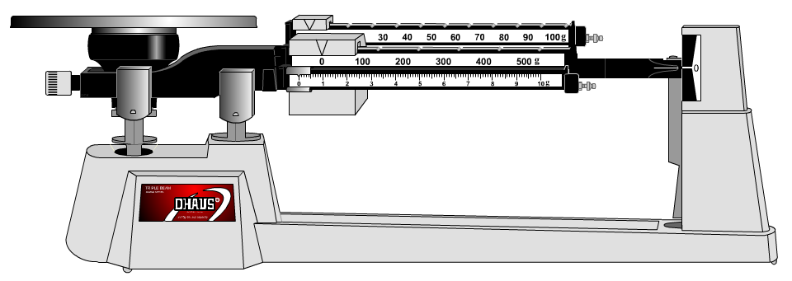
The triple beam balance is named for the three beams which carry weights.
A. The far beam weight can be set in ten gram increments.
B. The middle beam weight can be set in one hundred gram increments.
These weights must always be placed in a "notch". The weight should have its’ pointer toward a number.
C. The front beam weigh can be placed continuously between zero and ten grams. It has no notch.
Each one gram interval is further divided into 10 spaces or .1 gram. When you read any graduated scale you can always estimate between the smallest graduation marks. This allows the position of the weight to be estimated to the hundredth of a gram.

The following web sites provide tutorials on the parts of and use of the triple beam balance. Go through both of them.
http://www.ohaus.com/input/tutorials/tbb/TBBins.html
http://www.wisc-online.com/objects/ViewObject.aspx?ID=GCH202

The following web site provides practice reading a triple beam balance. Try a few different weights to check your understanding. The site only allows you to give answers to the tenths place.
http://www.ohaus.com/input/tutorials/tbb/TBBread.html

Triple Beam Balance Practice

- What is the mass of the rock on this triple beam balance (Figure 1) to the nearest centigram?
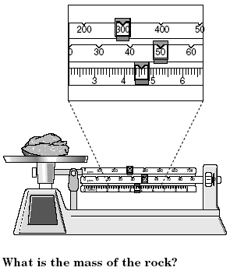
  - 300.40 grams
  - 350.60 grams
  - 354.8 grams
  - 354.60 grams Figure 1
  - 354.6 grams

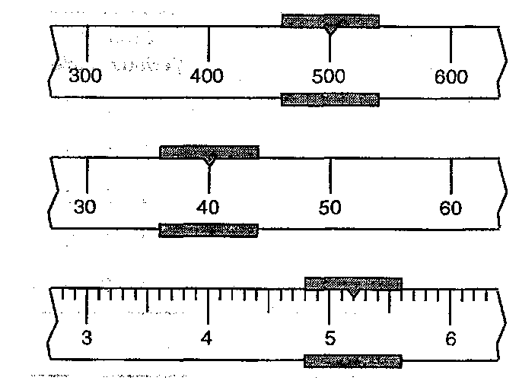
- The same rock is more scientifically measured to avoid contamination so it is placed in a beaker. What is the mass of the beaker if the total mass (rock and beaker) is seen in figure 2? Use figure 1 as well to answer question.
  - 190.60 grams
  - 200.20 grams
  - 184.50 grams
  - 206.70 grams
  - 110.50 grams

Section 9: The Graduated Cylinder

The graduated cylinder is an instrument for measuring liquid volumes. Common sizes range from ten milliliters to over one thousand milliliters.
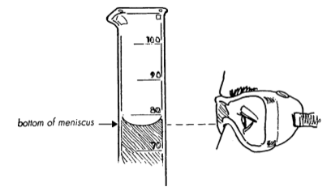

To read the graduated cylinder place it on a flat surface and view the height of the liquid in the cylinder with your eyes directly opposite the top of the liquid surface. The liquid will tend to curve downward. This curve is called a meniscus. Always read the bottom of the meniscus. Read the graduated cylinder to one tenth of the smallest division on the graduated cylinder.

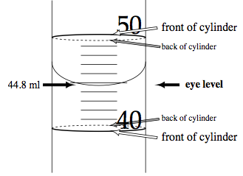
The diagram to the right shows how to observe the position of the wraparound rings on the cylinder to estimate when your eye is level with the meniscus. The ring above the observation point should have a mirror image with the ring below the observation point. Notice that the value of the meniscus reading is estimated to one tenth of the smallest division.

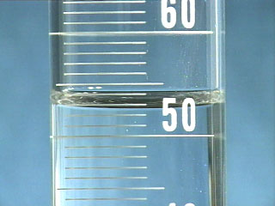

52.8 ml

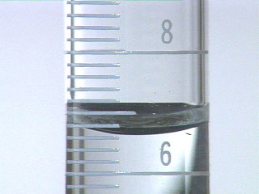
6.62 ml

Watch the following video on reading the graduated cylinder

http://www.youtube.com/watch?v=ZSvHNFf7Xmg&feature=related

The following powerpoint presentation will allow you to practice reading a graduated cylinder

http://www.wisc-online.com/objects/ViewObject.aspx?ID=gch302

Read the following graduated cylinders to the proper precision

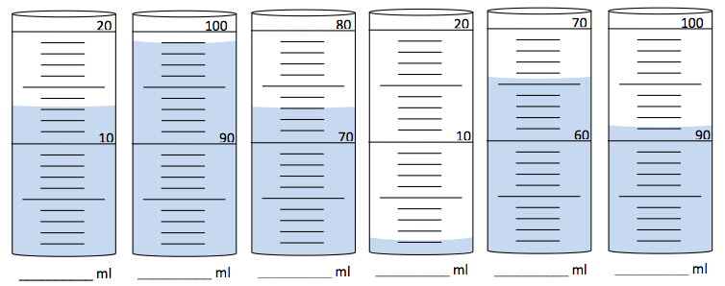

Draw in the meniscus for each of the following situations

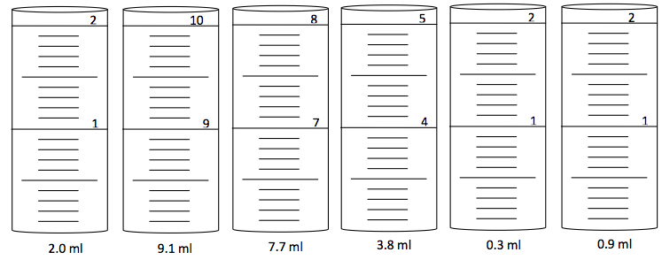

J
I
H
G
F
E
D
C
B
A
Section 10: The Scientific Approach
- Scientific Methods
  - Organized plan for gathering, organizing, and communicating information
  - Goal of any scientific method is to solve a problem or to better understand an observed event.
  - Know the path of the scientific method

A = Make an Observation
B = Ask a Question
C = Develop a Hypothesis
D = Test Hypothesis with an Experiment
E = Revise Hypothesis
F = Hypothesis is not supported
G = Develop a Theory
H = Hypothesis is supported
I = Analyze Data and Draw Conclusions
J = Test Hypothesis with Further Experiments

  - Variables
    - Manipulated variable – variable that causes change in another, one you are changing. This is also called the independent variable.
    - Responding variable – variable that changes in response to the manipulated variable. This is also called the dependent variable
  - Controlled experiments - experiment in which only one variable (manipulated) is deliberately changing at a time.
    - Other variables are kept constant
- Scientific Laws
  - Statement that summarizes a pattern found in nature
  - Doesn’t attempt to explain the pattern in nature
  - ex. Newton’s Laws of Motion
- Scientific Theories
  - Explanation of a pattern found in nature
  - ex. Darwin’s Theory of Natural Selection
- Scientific Models
  - Representation of an object or event
  - Make it easier to understand things that might be too difficult to observe directly

Section 11: Techniques of Graphing

After completing a laboratory investigation the data needs to be organized and presented in such a way as to help one draw conclusions concerning the experiment. While a data table is useful, it is difficult to discern general trends from this method of presentation. A more useful way to present the data obtained in the laboratory is to arrange it in graphical form. The following information will discuss some of the conventions and techniques that are observed in constructing graphs.

Determination of Coordinates:

Most physical science experiments involve two variables that change concurrently. To graph one variable with respect to the other, first select which variable is the independent variable and which is the dependent variable. For example, if weights are hung one after another from a spring, the spring stretches more with each additional weight. It is natural to consider the amount of stretching as being dependent on the total weight, rather than the other way around. Therefor the weight is the independent variable and the amount of stretching is the dependent variable. By convention, the independent variable is plotted on the horizontal or x-axis, while the dependent variable is plotted on the vertical or y-axis. It should be noted that this is not an absolute rule. The laboratory directions may also indicate how to set up your graph. For example, the directions might say “make a graph of total weight vs. stretch”. The first variable given is the dependent variable and the second is the independent variable.

Choosing the Scale:

After determining which variable is to be plotted on which axis, it is necessary to select a scale that will conveniently fill the graph paper area. This involves the determination of whether the long edge of the paper should be horizontal or vertical. An awkward scale should not be used in making a graph. Where possible, the divisions of the graph should be part of an easily identified series, such as 1-2-3 or 5-10-15 etc. The graph should be large enough to show the necessary details and relationships, but it should not be so large that the graph unduly magnifies small errors and renders relationships difficult to discern. For this reason "breaks" in the scale should be avoided. Unless otherwise indicated, start the scale from zero.

Labeling the Axis:

After the coordinate axes and scales are chosen, the scale number values should be written along the axis. The numbers should be written so that they may be read without turning the sheet. It is not necessary to clutter the graph by labeling every division. Number only the divisions that are both convenient and necessary for clarity. For example, every second, fourth, fifth, or tenth division might be numbered, depending on the convenience dictated by the scale. The labeling should provide adequate information for plotting and locating points readily without producing a crowded effect. After the numbers have been placed, it is necessary to designate in words, rather than in symbols, what is being plotted on each axis and the units in which the measurements are given. For example, one might put along the coordinates such labels as total hanging weight (N)
OVER
or stretch of spring (cm). The designation of what is being plotted along the horizontal axis is written so that it may be read when the graph is held normally. The designation of what is being plotted along the vertical axis is written in such a way so that it may be read when the graph is rotated 90 degrees clockwise.

Location of Points:

The points of the graph are located from the data. At the proper position a small dot is made.

Drawing the Curve:

The type of curve to be drawn depends upon the nature of the data. In some cases, it may be reasonably clear from the plotted points that the relation between the variables is linear. In this case, a straight edge should be used and a line drawn that will best represent an average value. This is done by having some of the points fall above the line and some fall below the line to balance the points as well as possible. In other cases, the points represent a nonlinear curve. In this case a line should be drawn with a smooth curve so that the points average around the line as well as possible. Do not connect the points.

Title:

Every graph should have a title. The title, which should be written in some space near the top of the graph, should state in words, rather than in abbreviations, the dependent variable as a function of the independent variable. For example: The Stretch of a Spring as a Function of Hanging Weights

Mathematical Model:

When analyzing the quantitative data that has been expressed graphically, one is often interested in discovering an exact mathematical expression, or model, of the data. Perhaps the simplest relationship that can exist between two variables is the case in which one of the variables varies directly with the other. That is, the graph results in a straight line. For this type of relationship the general mathematical model would be

y = mx + b

The letter “ b” represents where the straight line you have drawn intercepts the y axis and the letter “m” represents the slope of the line. The slope may be calculated by choosing two convenient, non-data, points on the line and then calculating the ratio of the rise of the line divided by the corresponding run of the line. A more formal expression of this calculation is:

Both the slope and the intercept may have real physical significance. It should be noted that the slope and intercept always have units. They are found by using the units of the axis.
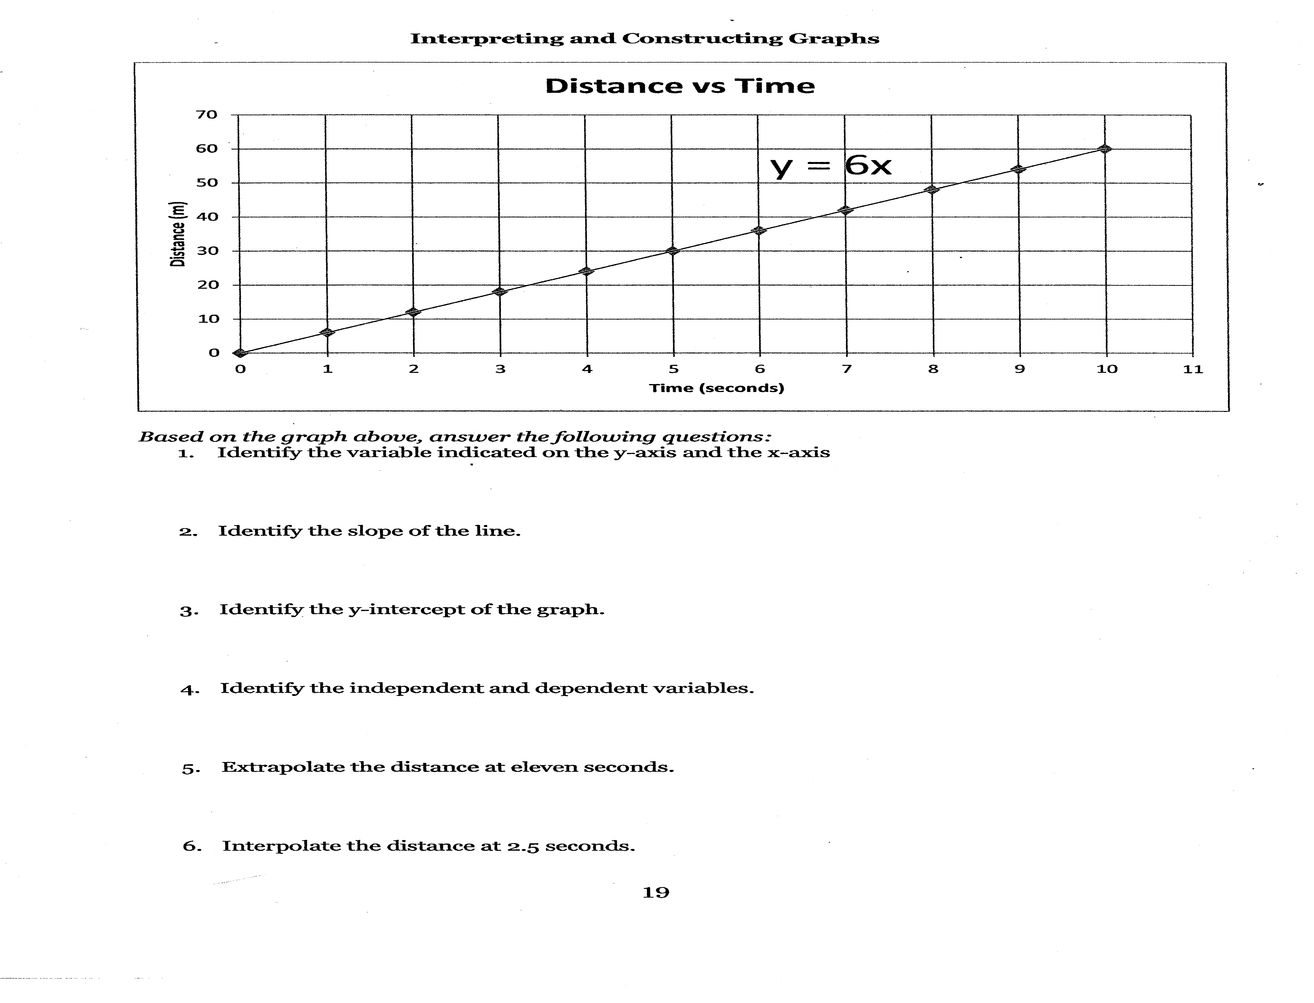

Example Graph:

The graph below shows an example of a properly constructed graph. While reviewing these directions locate and study each of the points discussed.

PRACTICE PROBLEMS: #1

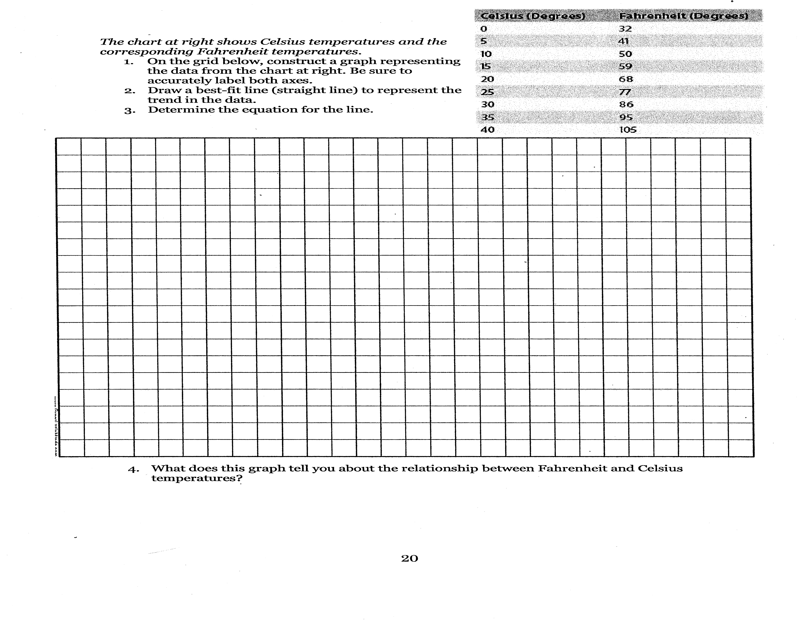

#2

#3
HINT: The following graph is challenging. The height is given as feet – inches. Your y-scale should have 3, 4, 6 or 12 gridlines in between each foot so you can easily divide the 12 inches comprising each foot.

For more help you can access the following two websites:

http://www.youtube.com/watch?v=Xn7Sd5Uu42A
http://www.youtube.com/watch?v=Ogx7CJ1JD9k

